**Import / Export feature**

* **Entity / Equipment Templates**

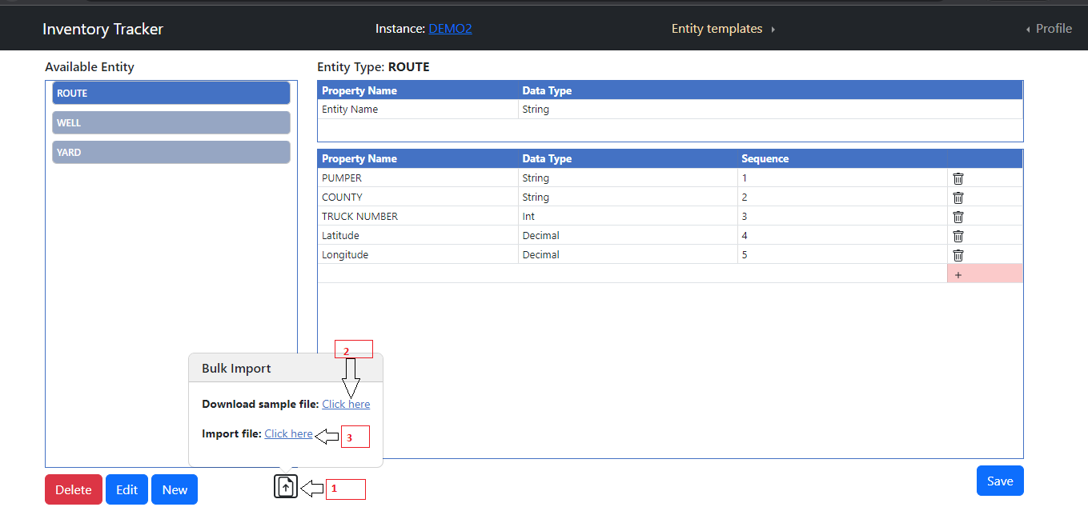

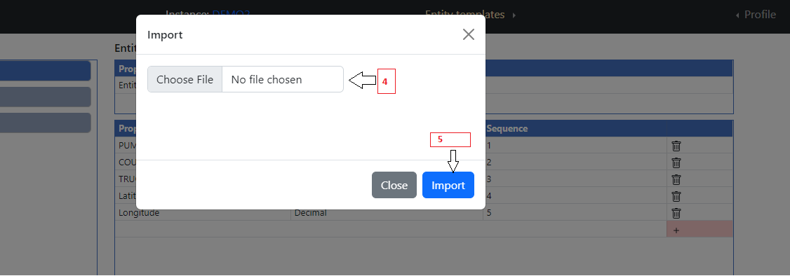

1. Click on Import file button.
2. If user wants to see the sample file, click on Download sample File Click here link.
3. User can fill the sample file with data and they can import the by clicking on Import File Click here button.
4. User can upload the file by Choose File option.
5. To Import the file, user can click on Import button.

* **Entity Templates Excel**

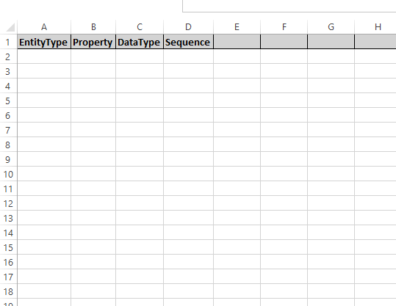

1. Entity Type – If New Entity type then it will create it else update existing entity type and add property into it.
2. Property – Property name.
3. Datatype – Which datatype data accepted by property. Datatype - String, Int, Decimal, Bool , Hyperlink , DateTime.
4. Sequence – In which sequence property display in entity create page.
5. **Note – New columns not allow into this functionality.**

* **Equipment Templates Excel**

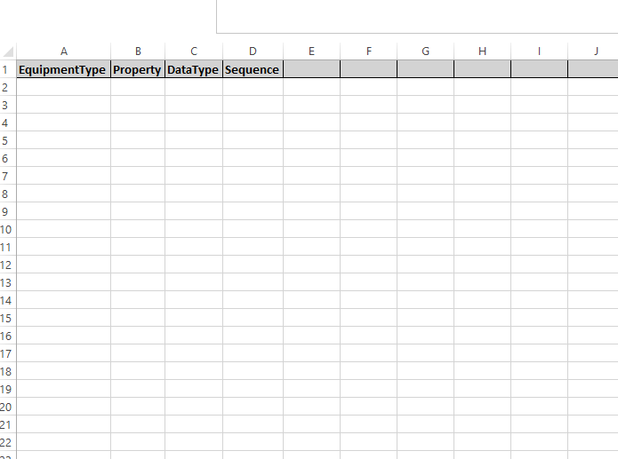

1. Equipment Type – If New Equipment type then it will create it else update existing Equipment type and add property into it.
2. Property – Property name.
3. DataType – Which datatype data accepted by property. Datatype - String, Int , Decimal , Bool , HyperLink , DateTime.
4. Sequence – In which sequence property display in equipment create page.
5. **Note – New columns not allow into this functionality.**

* **Entity / Equipment Search -> New Entity Import**

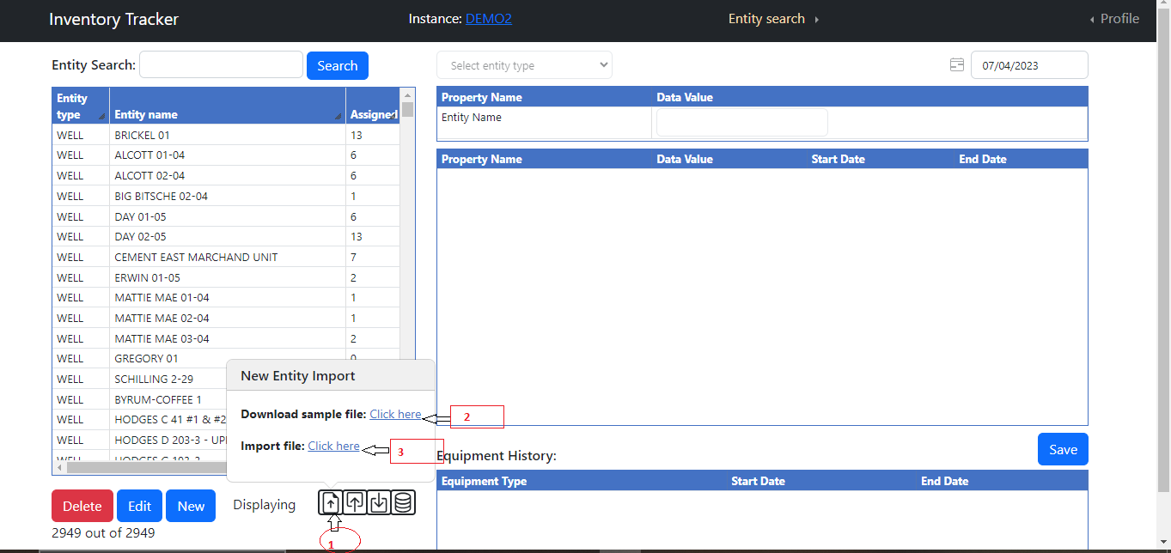



1. Click on Import file button.
2. If user wants to see the sample file, click on Download sample File Click here link.
3. User can fill the sample file with data and they can import the by clicking on Import File Click here button.
4. User can upload the file by Choose File option.
5. To Import the file, user can click on Import button.

* **Entity Bulk Import (New Entity Import)**

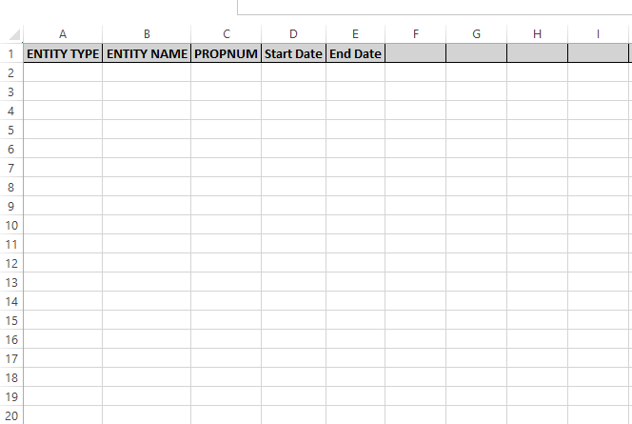

1. Entity Type – Entity type name must match with existing type.
2. Entity Name – Name of entity.
3. Propnum (Replace with Property name in header – ex. PROPNUM) – Property name of entity type must match with existing property name.
4. Start date – Start date.
5. End date - end date.
6. **Notes – More columns add in pair of Property Name (PROPNUM), Start Date, End Date.**

* **Equipment Bulk Import (New Entity Import)**

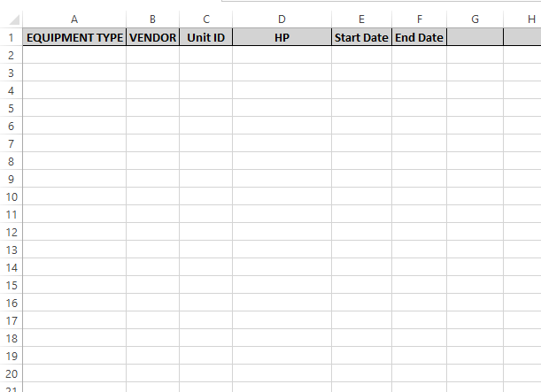

1. Equipment Type – Equipment type name must match with existing type.
2. Vendor – Vender name.
3. Unit ID – Unit ID.
4. Property Name (HP) (Replace with Property name in header) – Property name of Equipment type must match with existing property name.
5. Start date – Start date.
6. End date - end date.
7. **Notes – More columns add in pair of Property Name (HP), Start Date , End Date.**

* **Entity / Equipment Search -> Export**

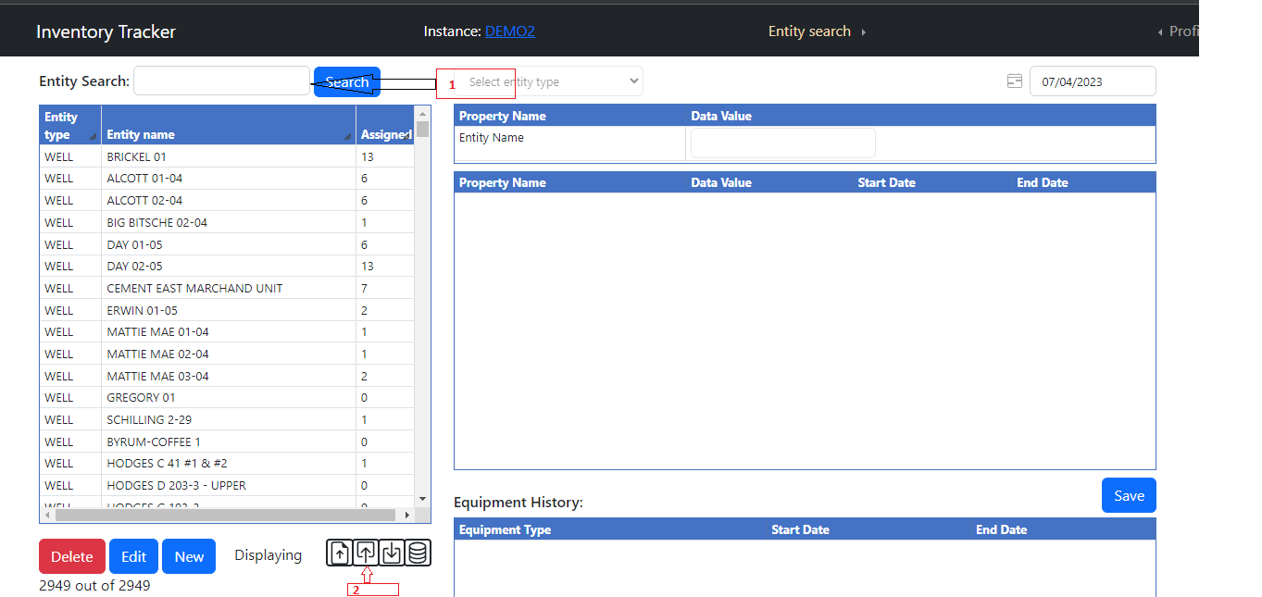

1. User can first search and then click on export button to export filtered data only.
2. Click on export button to export the data in Excel format.

* **Entity / Equipment Search -> Import**

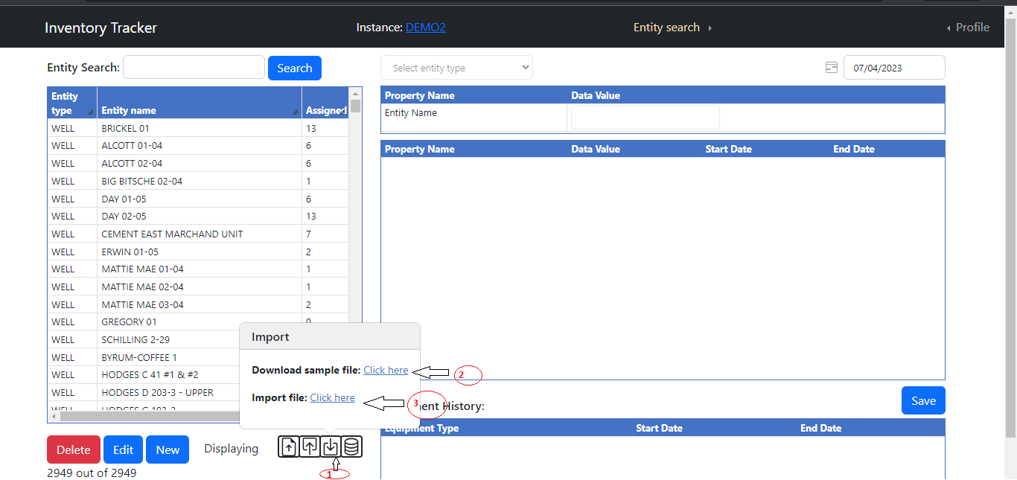



1. Click on Import file button.
2. If user wants to see the sample file, click on Download sample File Click here link.
3. User can fill the sample file with data and they can import the by clicking on Import File Click here button.
4. User can upload the file by Choose File option.
5. To Import the file, user can click on Import button.

* **Entity Import Excel**

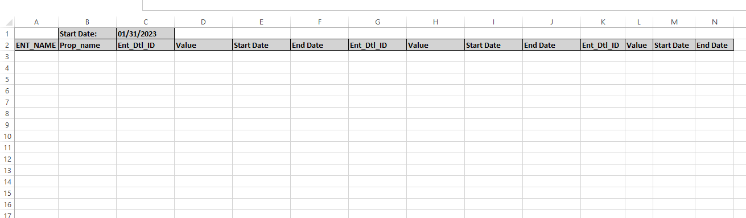

1. ENT_NAME – Entity Name (Auto filled).
2. Prop_name – Property name for entity(Auto filled).
3. Ent_Dtl_ID – No need to change for existing records and for new records this columns need to be empty.
4. Value – value for property.
5. Start Date – Start date for property.
6. End Date – End date for property.
7. **Note – First need to export excel then import it. ENT_NAME and Prop_Name not add / editable but autofilled. If Ent_Dtl_ID is there then it update record else new insert into database. No need to change existing Ent_Dtl_ID into excel.**
8. **If want to add more records then add columns in pair of Ent_Dtl_ID , Value , Start Date , End Date in the last and don’t change Ent_Dtl_ID column.**

* **Equipment Import Excel**

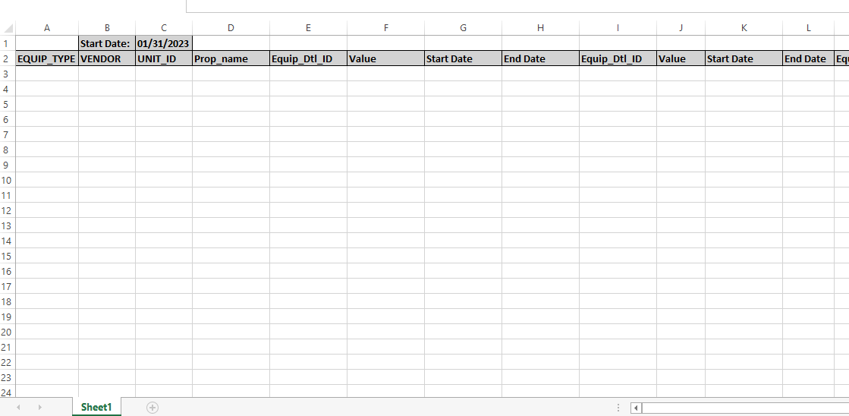

1. EQUIP_TYPE – Equipment type auto filled (Auto filled).
2. Vendor – Vendor name auto filled (Auto filled).
3. Unit_ID – Unit id for equipment type (Auto filled).
4. Prop_name – Property name for equipment (Auto filled).
5. Equip_Dtl_ID – No need to change for existing records and for new records this columns need to be empty.
6. Value – value for property.
7. Start Date – Start date for property.
8. End Date – End date for property.
9. **Note – EQUIP_TYPE , Vendor , Unit_ID and Prop_Name not add / editable but auto filled. If Equip_Dtl_ID is there then it update record else new insert into database. No need to change existing Equip _Dtl_ID into excel.**
10. **If want to add more records then add columns in pair of Equip_Dtl_ID , Value , Start Date , End Date in the last and don’t change Equip_Dtl_ID column.**

* **Equipment-Entity / Entity-Equipment Assignment -> Import Date Range**

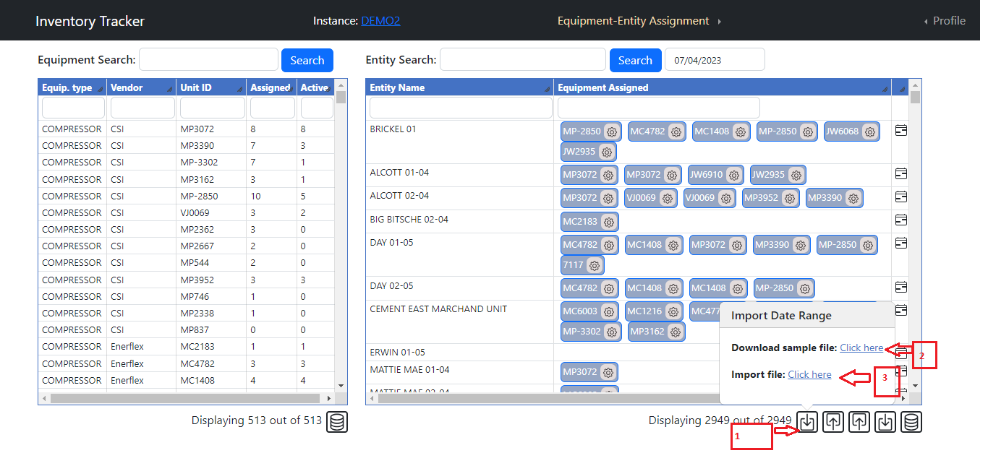

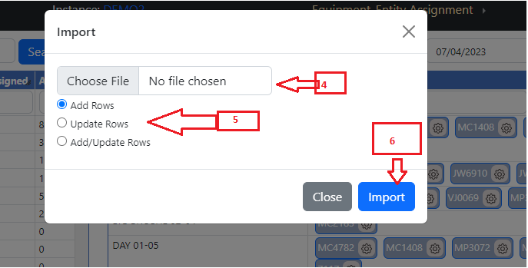

1. Click on Import Date Range button.
2. If user wants to see the sample file, click on Download sample File Click here link.
3. User can fill the sample file with data and they can import the by clicking on Import File Click here button.
4. User can upload the file by Choose File option.
5. Select which operation you need to perform. Default is Add Rows.

Add Row – It Adds the row into database table which is new.

Update Row – It updates records into database table which matches.

Add/Update Rows – It will add or update the rows into database.

1. To Import the file, user can click on Import button.

* **Equipment Entity Assign Date Range Excel**

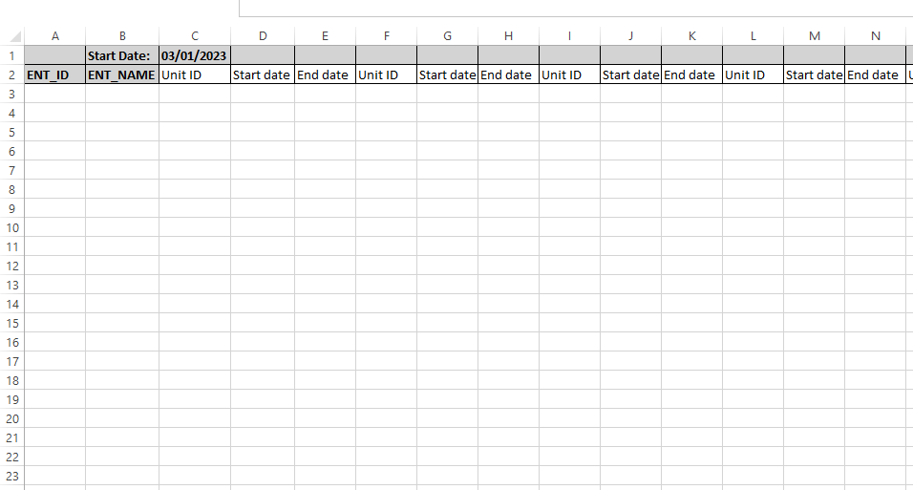

1. First you need to export date range excel and then edit it.
2. ENT_ID – Entity Id auto filled.
3. ENT_NAME – Entity name auto filled.
4. Unit ID – Unit Id of equipment.
5. **Notes – Columns addition is possible in pair of Unit ID , Start Date and End Date.**

* **Entity Equipment Assign Date Range Excel**

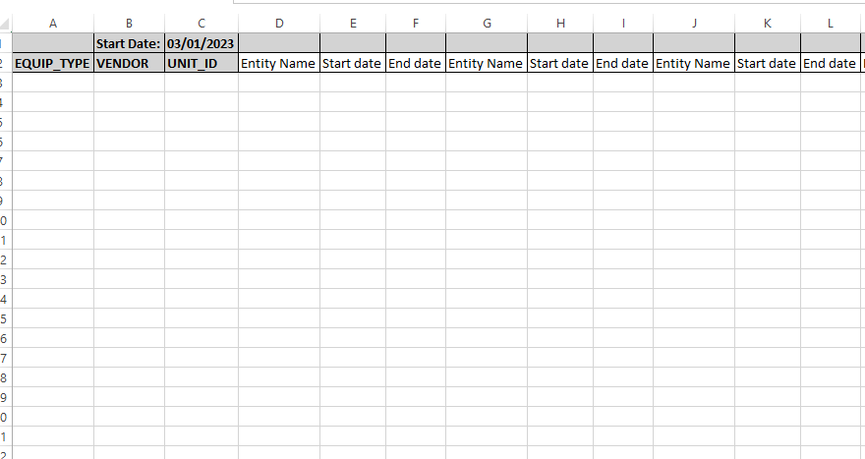

1. First you need to export date range excel and then edit it.
2. EQUIP_TYPE – Equipment type auto filled.
3. Vendor - Vendor auto filled.
4. Unit ID – Unit Id of equipment auto filled.
5. Entity Name – Entity Name of existing entity.
6. **Notes – Columns addition is possible in pair of Entity Name, Start Date and End Date.**

* **Equipment-Entity / Entity-Equipment Assignment -> Export Date Range**

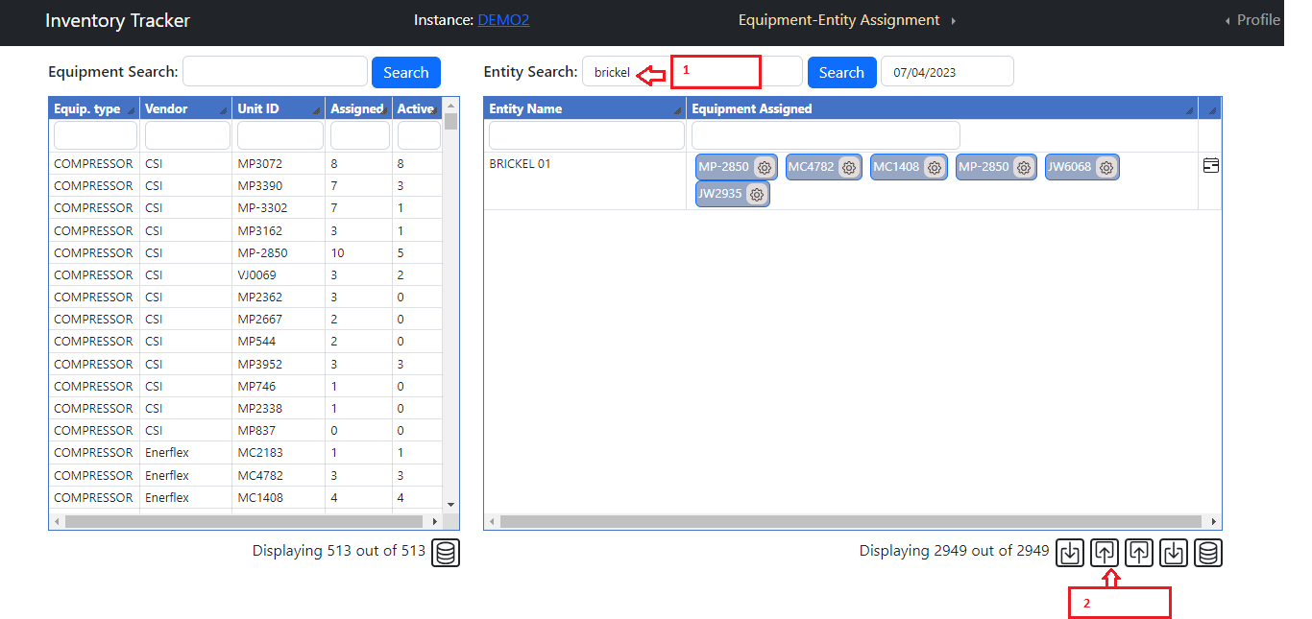

1. User can first search and then click on export button to export filtered data only.
2. Click on export date range button to export the data in Excel format.

* **Equipment-Entity / Entity-Equipment Assignment -> Export**

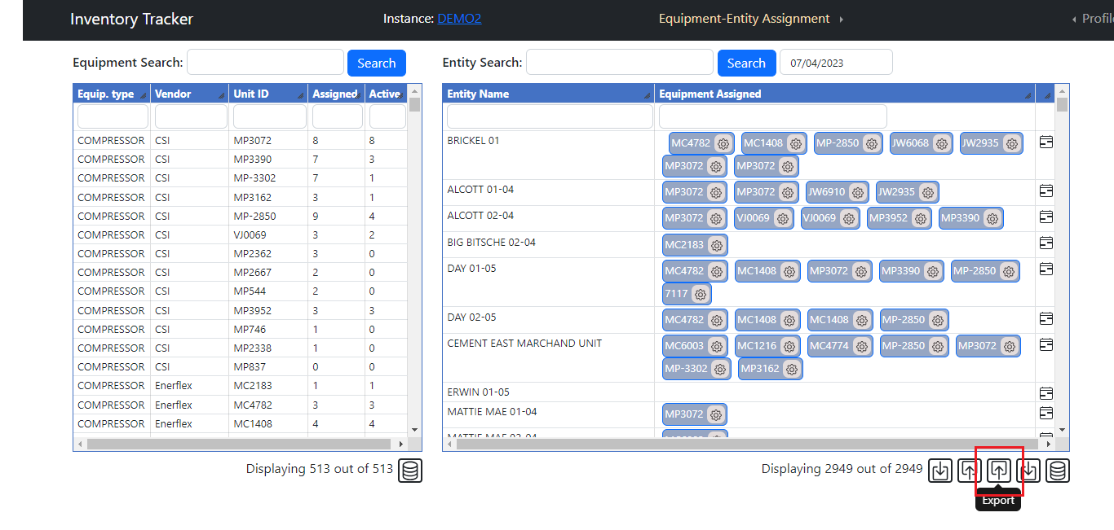

1. User can first search and then click on export button to export filtered data only.
2. Click on export button to export the data in Excel format.

* **Equipment-Entity / Entity-Equipment Assignment -> Import**

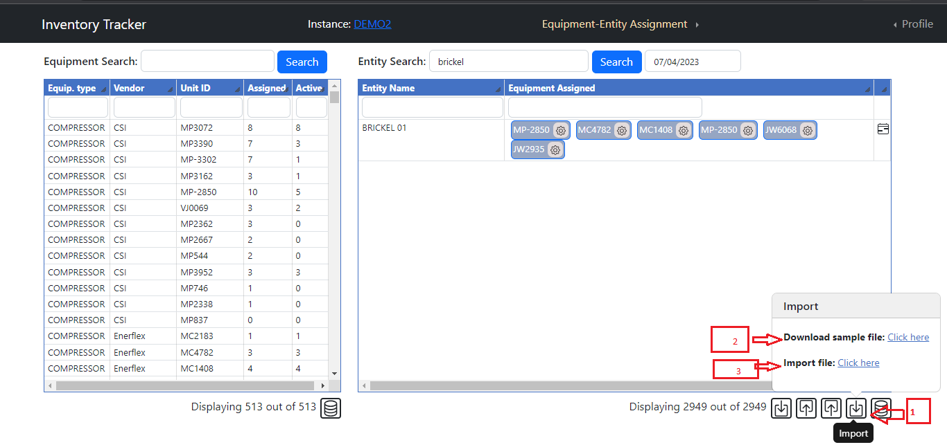



1. Click on Import file button.
2. If user wants to see the sample file, click on Download sample File Click here link.
3. User can fill the sample file with data and they can import the by clicking on Import File Click here button.
4. User can upload the file by Choose File option.
5. To Import the file, user can click on Import button.

* **Equipment Entity Assignment Import Excel**

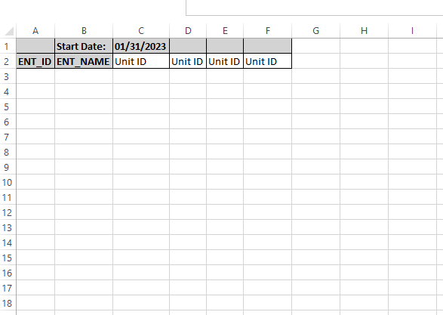

1. First you need to export excel and then edit it.
2. ENT_ID – Entity Id auto filled.
3. ENT_NAME – Entity name auto filled.
4. Unit ID – Unit Id of equipment.
5. **Notes – Columns addition is possible in pair of Unit ID only.**

* **Entity Equipment Assignment Import Excel**

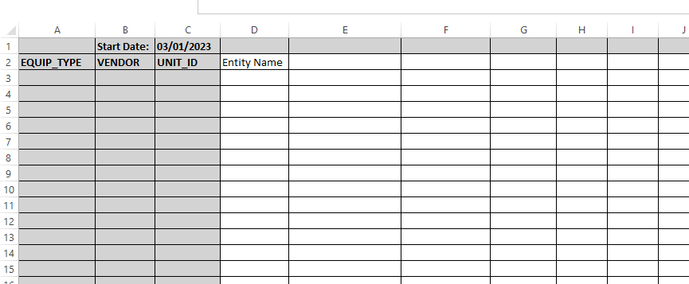

1. First you need to export excel and then edit it.
2. EQUIP_TYPE – Equipment type auto filled.
3. Vendor - Vendor auto filled.
4. Unit ID – Unit Id of equipment auto filled.
5. Entity Name – Entity Name of existing entity.
6. **Notes – Columns addition is possible in pair of Entity only.**

**Add / Edit feature**

* **Add New Equipment / Entity**

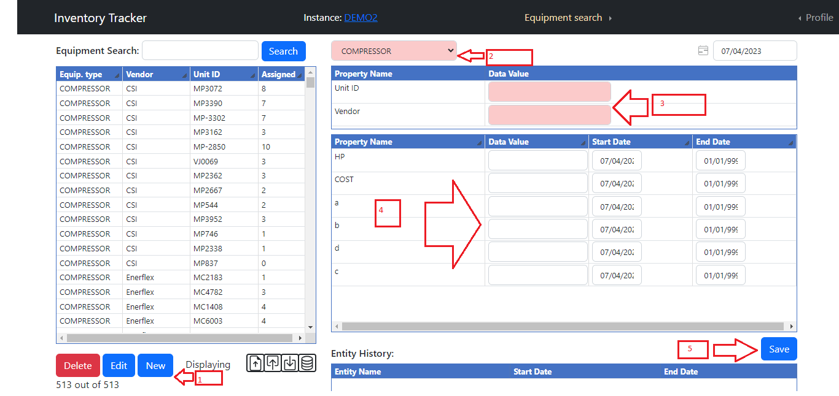

1. Click on New button.
2. Select Equipment type from dropdown list. (required)
3. Enter Unit ID and Vendor (required fields)
4. Enter Data into text box for all properties before save it.
5. Click on Save button to save the data into database.
6. User can change the date to store the data for that particular date.

* **Edit Equipment /Entity**

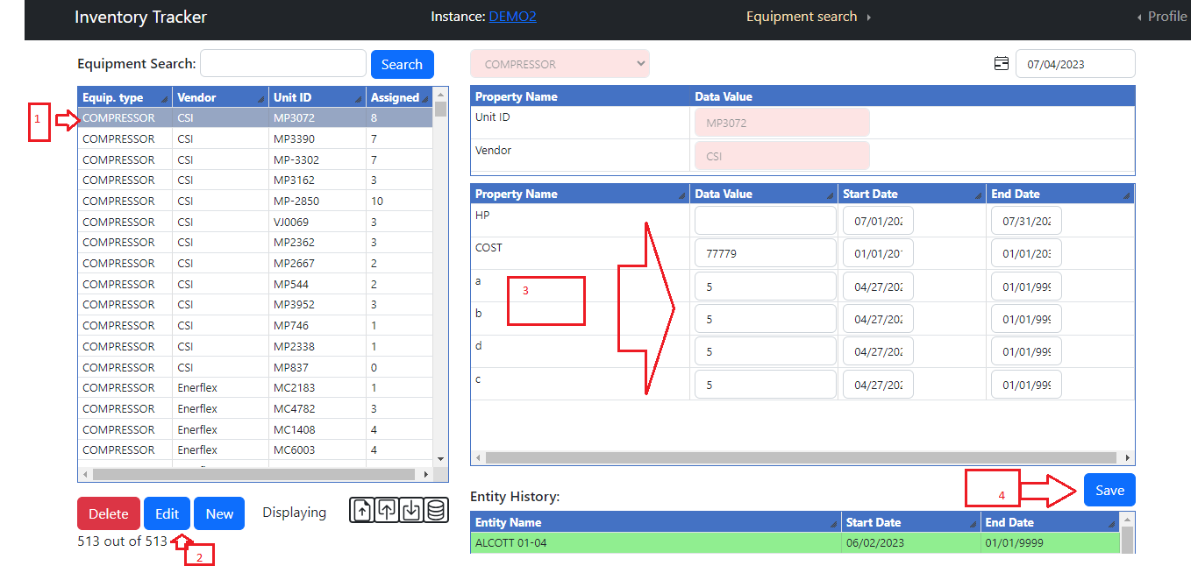

1. Search/Select equipment from left section to edit it.
2. Click on edit button.
3. Update values in the list for properties.
4. To save the updated data, click on Save button.

**Equipment – Entity /Entity- Equipment Assignment**

* **Equipment and Entity search**

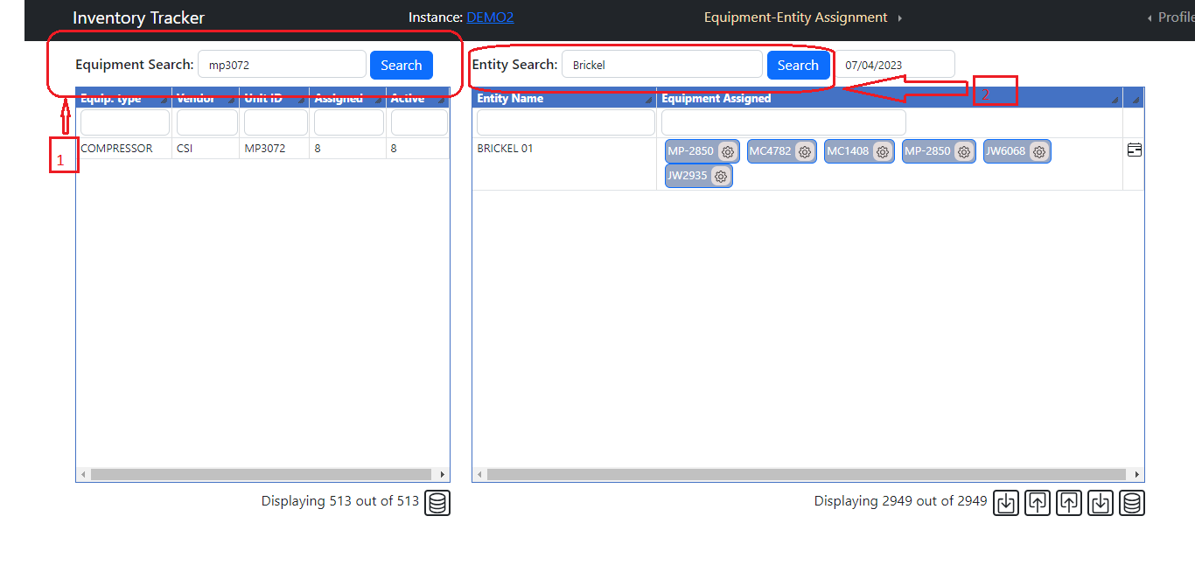

1. Enter search text on Equipment / Entity search text box then click on Search button or press Enter key it will filter data and display in respective tables.

* **Date functionality**

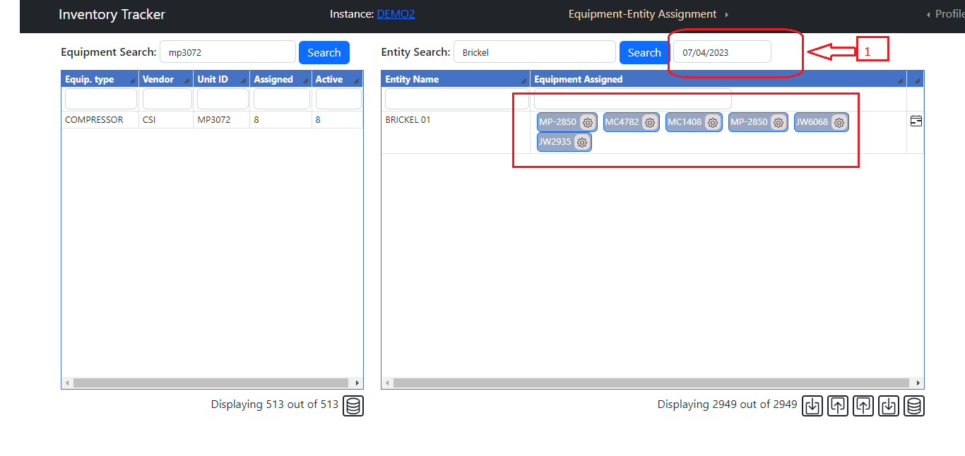

1. Based on this date all assigned data will display in Equipment Assignment Table.

* **Column chooser**

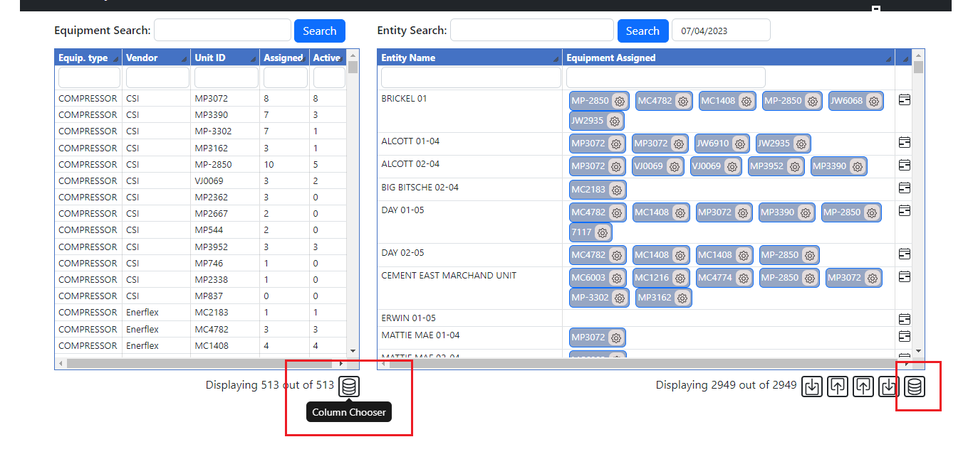

1. Click on column chooser icon, it will open below popup for add column into respective table.

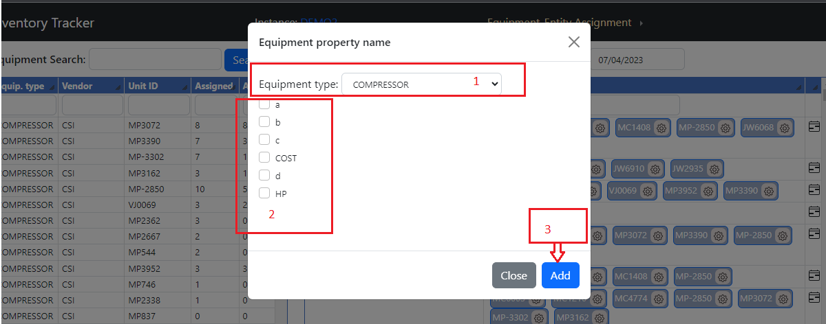

1. Select Equipment type then select property name and click on add button. It will add property name columns into table.

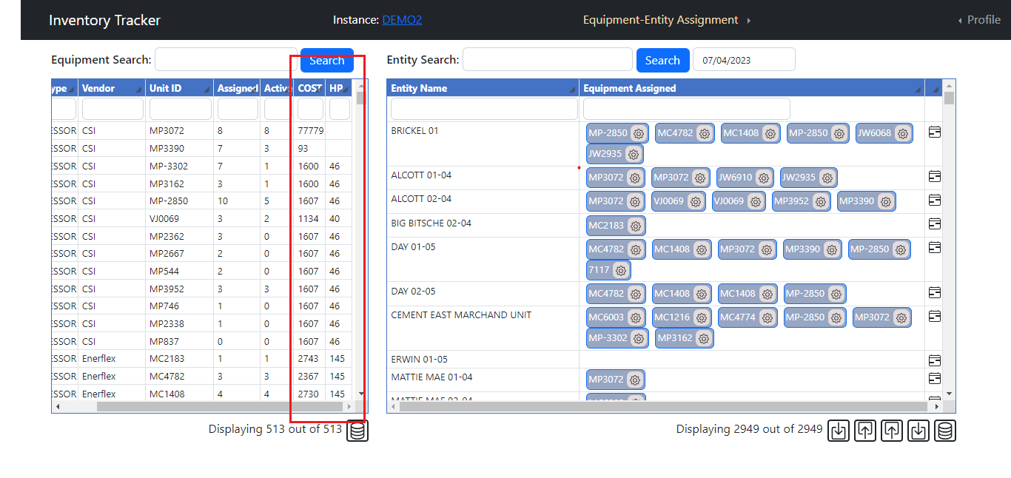

1. All columns are sortable and resizable.

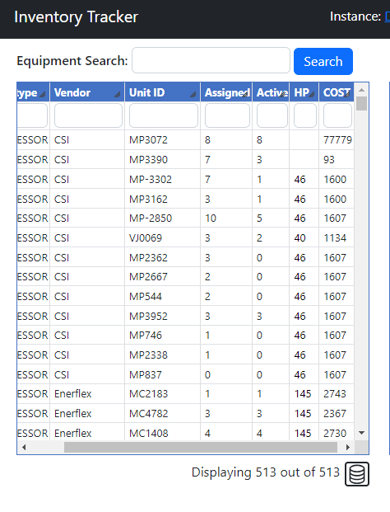

* **Calendar Control**

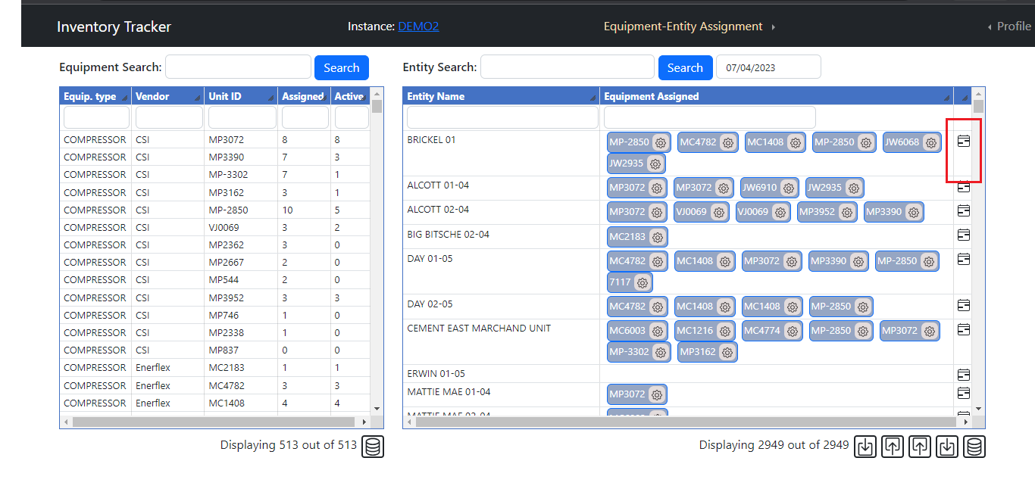

1. Click on this calendar control it will open below screen.

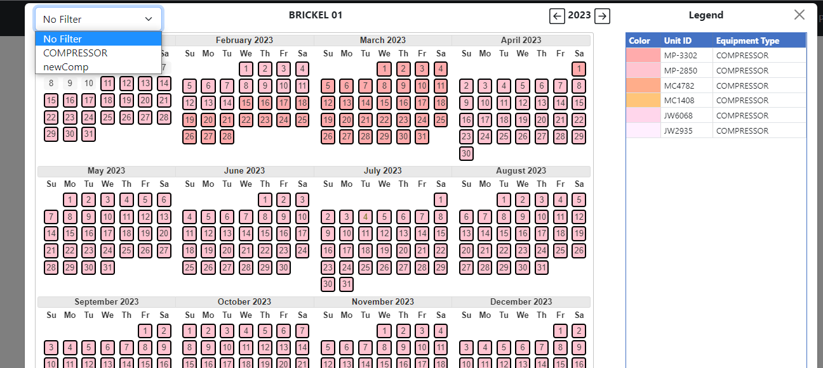

1. It will display all equipment type which is assigned for selected date range.

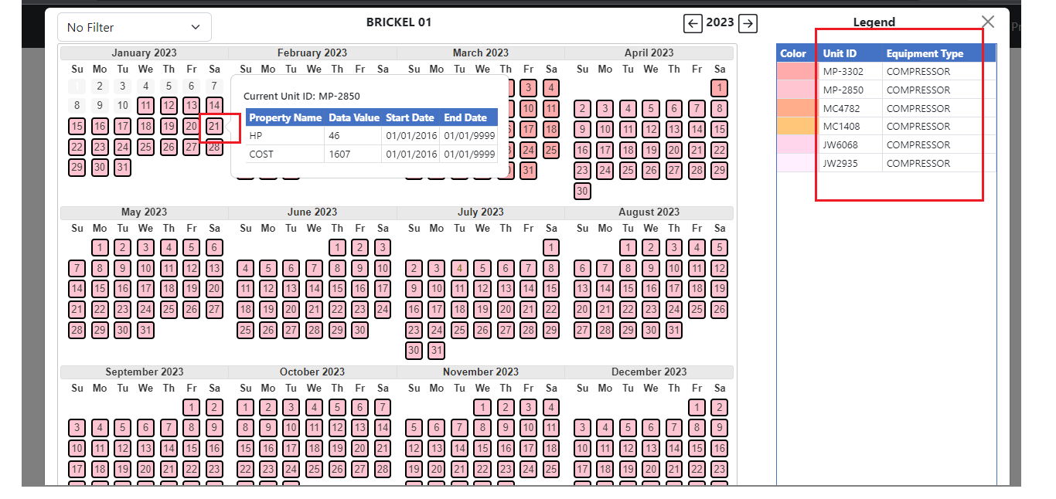

1. If we click on calendar date or any equipment type then it will show below popup for add / update or remove data for that date range.

For Update Date range of Unit ID

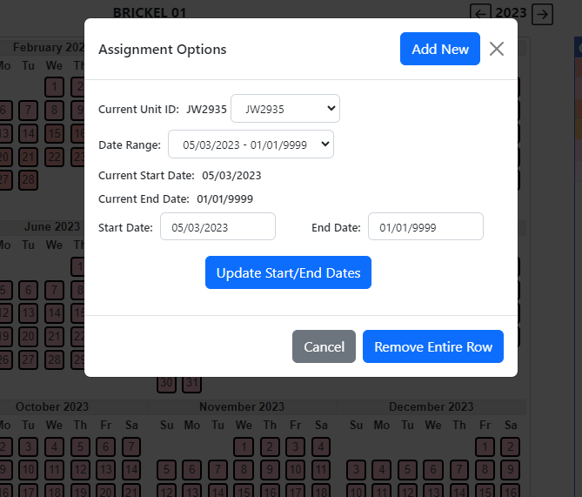

* Change Start/End date or both and click on update to update that record for that date.
* Click on Remove entire row for remove selected row.
* Change Unit Id dropdown for select other unit id.

1. For Add Date range

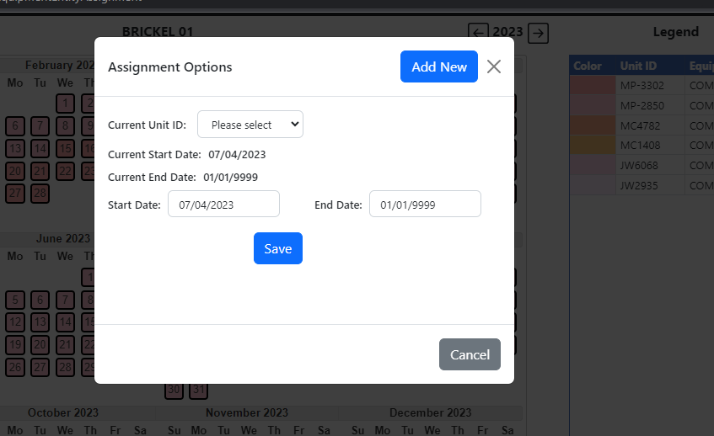

1. Select Unit Id and enter start and end date then save it.

* **Color functionality**

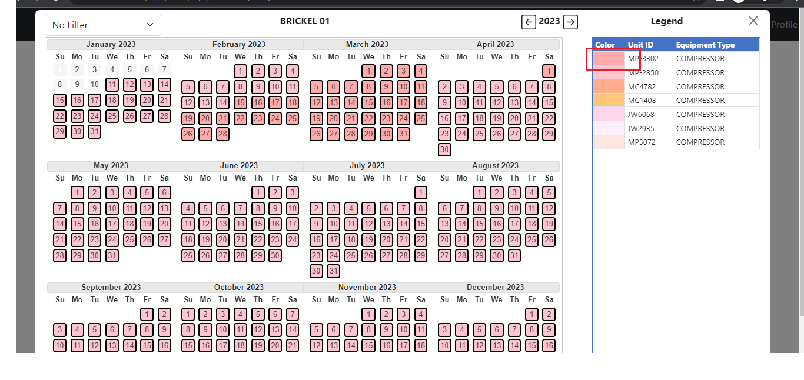

1. Click on this color it will open below popup for change color.

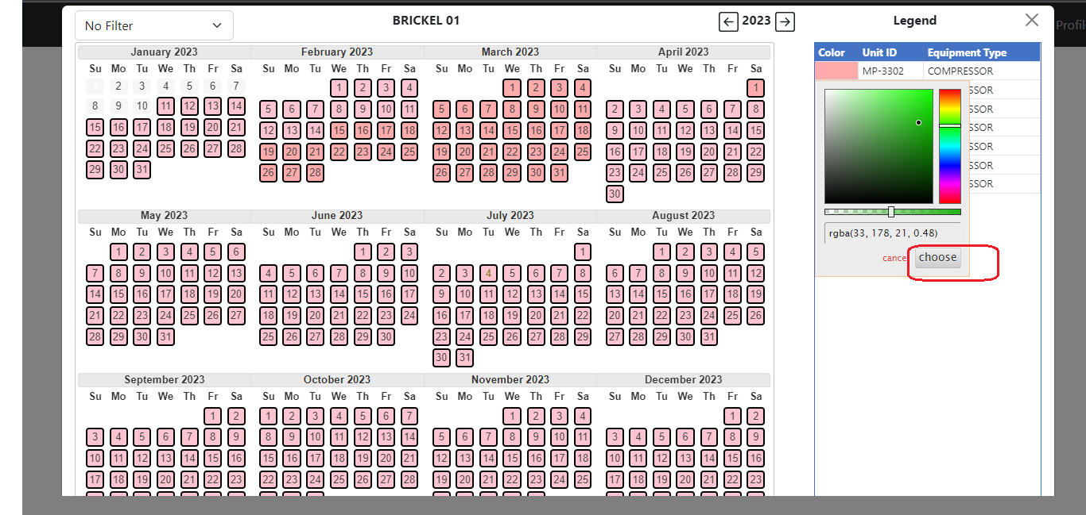

1. Select color and click on choose button. It will change color of selected Unit Id into calendar control.

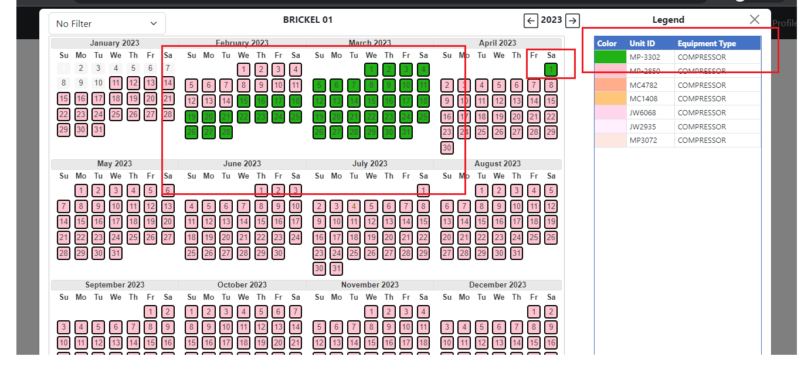

* **Assignment Options**

1. Click on gear icon it will open popup for update start / end date or remove entire row.

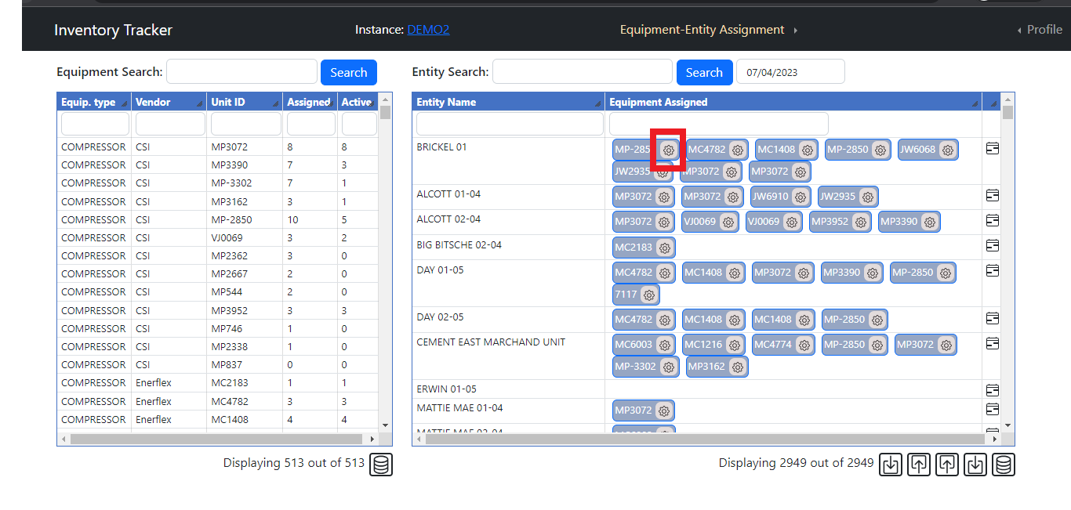

* Change start date or end date or both then click on Update Start/End Dates it will update it for selected Unit ID. (1)
* If you need to remove specific Date range for selected table then click on remove entire row it will remove it. (2)

